Ktique German Shepherd Dogs
Questionnaire
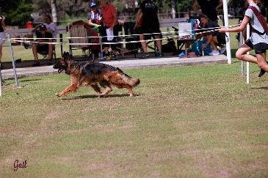

- Your name:

- Your address:

- Your email address:

- Your mobile number:

- Are interested in a pet or a show dog?

- Male or female or are you open to either?

- Have you had any experience with German Shepherds?

- How many other pets do you have? Please list type/age/breed.

- Do you have children, if yes, how old are they? We like to match puppies to buyers re energy levels.

- Do the adults work outside the home?

- How many hours a day would the dog be left alone?

- How do you feel about potentially everything being destroyed which is left out in the puppy’s area? i.e. shoes, clothes, toys, rugs, tables.

Our philosophy is to set a puppy up for success so we fully recommend puppy proofing areas if you are concerned about damage because they will chew and quite often dig.

- Which age category are you in? 18 – 29, 30 – 49, 50 – 69 or 70+

Please send us some photos of your home, other pets and family if you are comfortable with this.

Prices:
Pet home puppies are $5,000
Show home puppies are $5,500

All puppies are Micro-Chipped, Vaccinated, Wormed, Vet Checked and have Pedigree Papers. They come with 6 weeks free Pet Insurance (if requested) and a Gift Bag with lots of goodies.

Terms and Conditions:
Once your application is approved and when the puppies are born, we do require a $1000 holding deposit

(The deposit is refundable if you meet the puppies and are not happy for any reason, you will need to notify us within 24 hours after the meeting, normally this is when the puppies are 4 weeks old, we will have a dedicated Facebook page where you can watch closely their development and feel part of their journey. The deposit will be paid back when a new deposit is received less an Administration Fee of $150.)

Preference of puppies is given to the buyer who pays their deposit first, we normally ask you to choose your top preference of 2 or 3 puppies after you have met them and we will look at the puppies personalities and try to match them to the buyers lifestyle etc. (This does not include the Show puppy/s.)
We have never had a buyer who has been unhappy using this system.

