**Ktique German Shepherd Dogs**

**Questionnaire**

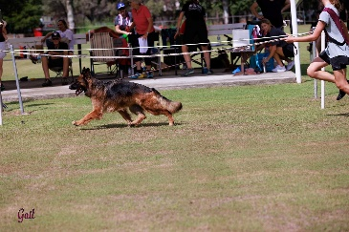

1. Your name:
2. Your address:
3. Your email address:
4. Your mobile number:
5. Are interested in a pet or a show dog?
6. Male or female or are you open to either?
7. Are you happy with a Stock Coat or Long Stock Coat?
8. Have you had any experience with German Shepherds?
9. How many other pets do you have? Please list type/age/breed.
10. Do you have children, if yes, how old are they? We like to match puppies to buyers re energy levels.
11. Do the adults work outside the home?
12. How many hours a day would the dog be left alone?
13. How do you feel about potentially everything being destroyed which is left out in the puppy’s area? i.e. shoes, clothes, toys, rugs, tables.

Our philosophy is to set a puppy up for success so we fully recommend puppy proofing areas if you are concerned about damage because they will chew and quite often dig.

1. Which age category are you in? 18 – 29, 30 – 49, 50 – 69 or 70+

Please send us some photos of your home, other pets and family.

Prices:

Pet home puppies are $5,000

Show home puppies are $5,500

All puppies are Micro-Chipped, Vaccinated, Wormed, Vet Checked and have Pedigree Papers. They come with 6 weeks free Pet Insurance and a Gift Bag with lots of goodies.

Terms and Conditions:

Once your application is approved and when the puppies are born, we do require a $1000 holding deposit

(The deposit is only refundable if prior or within 24 hours after you have seen the litter, normally this is when the puppies are 4 weeks old, we will have a dedicated Facebook page where you can watch closely their development and feel part of their journey. The deposit will be paid back when a new deposit is received less an Administration Fee of $50.)